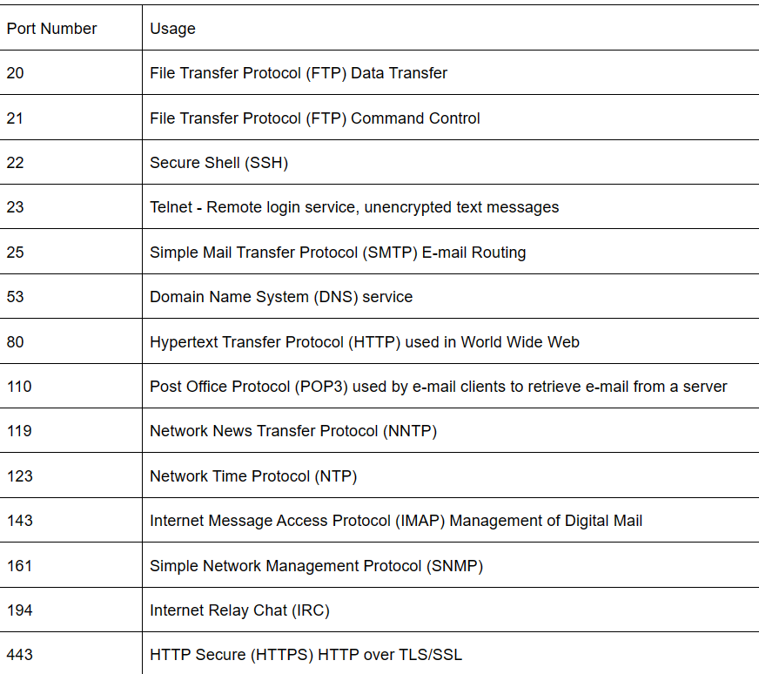

[50 Common Ports You Should Know - GeeksforGeeks](https://www.geeksforgeeks.org/50-common-ports-you-should-know/)